**Week 3 & Week 4 Assignment Solutions**

**Q1.**

**Ans1.**

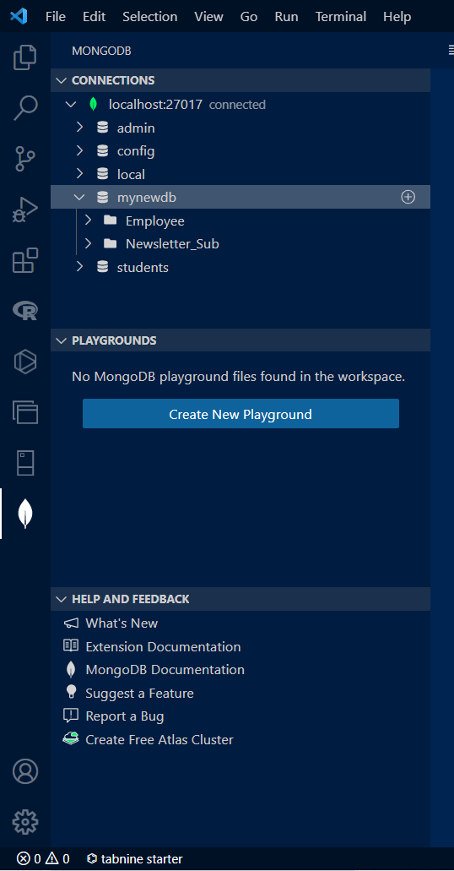

**Q2.**

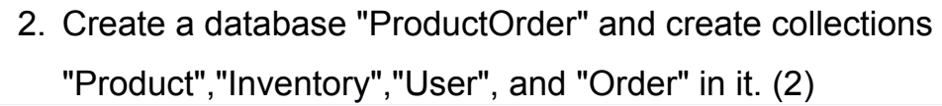

**Ans2.**

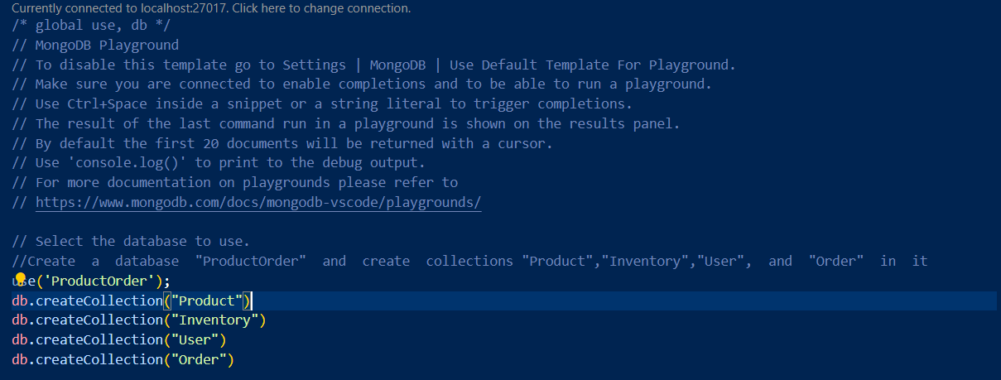

**Result ->**

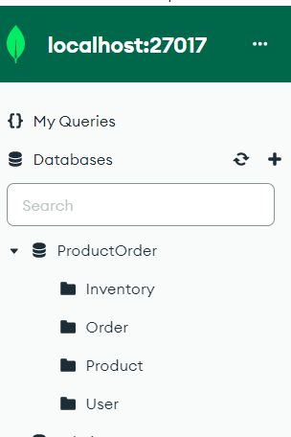

**Q3.**

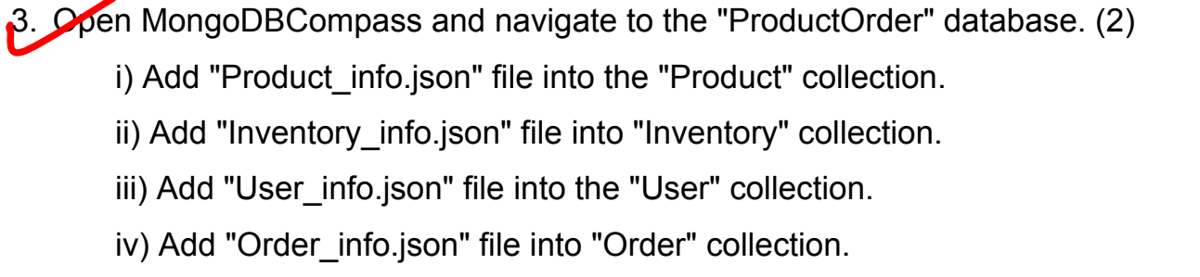

**Ans3**

**It was done for all.**

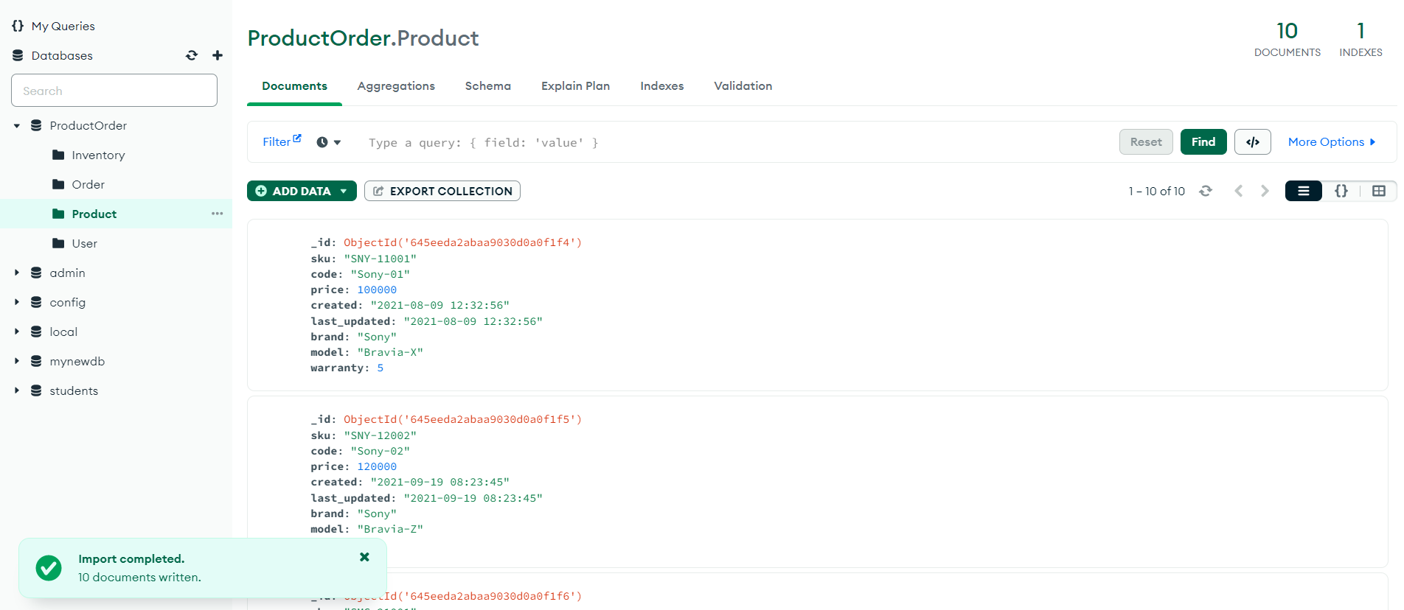

**Q4.** **Display the first 5 rows of product, inventory, user, and order collection.**

db.Product.find().limit(5)

**Output-**

[

  {

    "_id": {

      "$oid": "645eeda2abaa9030d0a0f1f4"

    },

    "sku": "SNY-11001",

    "code": "Sony-01",

    "price": 100000,

    "created": "2021-08-09 12:32:56",

    "last_updated": "2021-08-09 12:32:56",

    "brand": "Sony",

    "model": "Bravia-X",

    "warranty": 5

  },

  {

    "_id": {

      "$oid": "645eeda2abaa9030d0a0f1f5"

    },

    "sku": "SNY-12002",

    "code": "Sony-02",

    "price": 120000,

    "created": "2021-09-19 08:23:45",

    "last_updated": "2021-09-19 08:23:45",

    "brand": "Sony",

    "model": "Bravia-Z",

    "warranty": 5

  },

  {

    "_id": {

      "$oid": "645eeda2abaa9030d0a0f1f6"

    },

    "sku": "SMG-21001",

    "code": "Samsung-01",

    "price": 66000,

    "created": "2021-07-13 16:46:32",

    "last_updated": "2021-07-13 16:46:32",

    "brand": "Samsung",

    "model": "XZ",

    "warranty": 3

  },

  {

    "_id": {

      "$oid": "645eeda2abaa9030d0a0f1f7"

    },

    "sku": "LLG-32001",

    "code": "LG-01",

    "price": 64000,

    "created": "2021-10-28 18:34:21",

    "last_updated": "2021-10-28 18:34:21",

    "brand": "LG",

    "model": "ZX",

    "warranty": 3

  },

  {

    "_id": {

      "$oid": "645eeda2abaa9030d0a0f1f8"

    },

    "sku": "PNS-18001",

    "code": "Panasonic-01",

    "price": 62000,

    "created": "2021-11-01 19:21:00",

    "last_updated": "2021-11-01 19:21:00",

    "brand": "Panasonic",

    "model": "LY",

    "warranty": 3

  }

]

 db.Inventory.find().limit(5)

**Output-**

[

  {

    "_id": {

      "$oid": "645eedb3abaa9030d0a0f1ff"

    },

    "sku": "SNY-11001",

    "quantity": 100,

    "last_updated": "2021-11-18 18:19:27"

  },

  {

    "_id": {

      "$oid": "645eedb3abaa9030d0a0f200"

    },

    "sku": "SNY-12002",

    "quantity": 80,

    "last_updated": "2021-12-01 23:12:45"

  },

  {

    "_id": {

      "$oid": "645eedb3abaa9030d0a0f201"

    },

    "sku": "SMG-21001",

    "quantity": 400,

    "last_updated": "2021-10-31 19:30:18"

  },

  {

    "_id": {

      "$oid": "645eedb3abaa9030d0a0f202"

    },

    "sku": "LLG-32001",

    "quantity": 450,

    "last_updated": "2021-11-28 12:34:56"

  },

  {

    "_id": {

      "$oid": "645eedb3abaa9030d0a0f203"

    },

    "sku": "PNS-18001",

    "quantity": 500,

    "last_updated": "2021-12-01 11:34:21"

  }

]

db.User.find().limit(5)

**Output-**

[

  {

    "_id": {

      "$oid": "645eedc0abaa9030d0a0f20a"

    },

    "name": "Anjali Gupta",

    "email": "anjali.gupta@zestmail.com",

    "created": "2020-12-08 13:01:56",

    "last_accessed": "2021-12-04 13:23:00",

    "role": "Customer"

  },

  {

    "_id": {

      "$oid": "645eedc0abaa9030d0a0f20b"

    },

    "name": "Kevin Curran",

    "email": "currank@zestmail.com",

    "created": "2021-08-15 09:10:11",

    "last_accessed": "2021-11-30 09:00:23",

    "role": "Supplier"

  },

  {

    "_id": {

      "$oid": "645eedc0abaa9030d0a0f20c"

    },

    "name": "Sudha Natarajan",

    "email": "sudha.nat@yourmail.com",

    "created": "2021-06-14 12:12:24",

    "last_accessed": "2021-12-05 08:34:56",

    "role": "Customer"

  },

  {

    "_id": {

      "$oid": "645eedc0abaa9030d0a0f20d"

    },

    "name": "Nabil Jamal",

    "email": "nabil.jamal@thatmail.com",

    "created": "2020-11-16 08:30:45",

    "last_accessed": "2021-11-29 10:13:09",

    "role": "Customer"

  },

  {

    "_id": {

      "$oid": "645eedc0abaa9030d0a0f20e"

    },

    "name": "Clara Kingston",

    "email": "clara.king@evermail.com",

    "created": "2021-08-09 23:12:00",

    "last_accessed": "2021-12-02 11:45:02",

    "role": "Customer"

  }

]

db.Order.find().limit(5)

**Output-**

[

  {

    "_id": {

      "$oid": "645eedccabaa9030d0a0f217"

    },

    "created": "2021-12-06 23:12:09",

    "last_updated": "2021-12-07 20:30:01",

    "items": [

      {

        "product_sku": "SNY-11001",

        "unit_price": 100000,

        "quantity": 1

      }

    ],

    "total_price": 100000,

    "discount": 10000,

    "net_price": 90000,

    "status": 1,

    "user_email": "sudha.nat@yourmail.com"

  },

  {

    "_id": {

      "$oid": "645eedccabaa9030d0a0f218"

    },

    "created": "2021-12-07 12:18:01",

    "last_updated": "2021-12-07 23:59:59",

    "items": [

      {

        "product_sku": "SMG-21001",

        "unit_price": 66000,

        "quantity": 1

      },

      {

        "product_sku": "LLG-32001",

        "unit_price": 64000,

        "quantity": 1

      },

      {

        "product_sku": "PNS-18001",

        "unit_price": 62000,

        "quantity": 1

      }

    ],

    "total_price": 192000,

    "discount": 19200,

    "net_price": 172800,

    "status": 3,

    "user_email": "currank@zestmail.com"

  },

  {

    "_id": {

      "$oid": "645eedccabaa9030d0a0f219"

    },

    "created": "2021-12-08 08:36:45",

    "last_updated": "2021-12-08 09:00:55",

    "items": [

      {

        "product_sku": "SNY-12002",

        "unit_price": 120000,

        "quantity": 1

      },

      {

        "product_sku": "LLG-32001",

        "unit_price": 64000,

        "quantity": 1

      }

    ],

    "total_price": 184000,

    "discount": 18400,

    "net_price": 165600,

    "status": 2,

    "user_email": "nabil.jamal@thatmail.com"

  },

  {

    "_id": {

      "$oid": "645eedccabaa9030d0a0f21a"

    },

    "created": "2021-12-08 02:18:46",

    "last_updated": "2021-12-08 02:20:24",

    "items": [

      {

        "product_sku": "SNY-12002",

        "unit_price": 120000,

        "quantity": 1

      }

    ],

    "total_price": 120000,

    "discount": 12000,

    "net_price": 108000,

    "status": 2,

    "user_email": "anjali.gupta@zestmail.com"

  },

  {

    "_id": {

      "$oid": "645eedccabaa9030d0a0f21b"

    },

    "created": "2021-12-07 22:56:23",

    "last_updated": "2021-12-07 23:00:00",

    "items": [

      {

        "product_sku": "SMG-21001",

        "unit_price": 66000,

        "quantity": 1

      }

    ],

    "total_price": 66000,

    "discount": 6600,

    "net_price": 59400,

    "status": 2,

    "user_email": "sudha.nat@yourmail.com"

  }

]

**Q5.** **Display the Unique Brand and Model names from the Product collection.**

**Unique Model**

db.Product.distinct("model")

[

  "A",

  "AP1",

  "Bravia-X",

  "Bravia-Z",

  "G",

  "GO1",

  "LY",

  "N",

  "XZ",

  "ZX"

]

**Unique Brand**

db.Product.distinct("brand")

[

  "AppleTV",

  "GoogleTV",

  "Haier",

  "LG",

  "Panasonic",

  "Samsung",

  "Sony"

]

**Q6.** **Find the maximum and minimum price of the given products.**

**Maximum Price->**db.Product.find().sort({price:-1}).limit(1) // for MAX

**Output-**

[

  {

    "_id": {

      "$oid": "645eeda2abaa9030d0a0f1fc"

    },

    "sku": "APL-01001",

    "code": "AppleTV-01",

    "price": 150000,

    "created": "2021-11-05 18:32:09",

    "last_updated": "2021-11-05 18:32:09",

    "brand": "AppleTV",

    "model": "AP1",

    "warranty": 5

  }

]

**Minimum Price**

db.Product.find().sort({price:1}).limit(1) // for MIN

**Output-**

[

  {

    "_id": {

      "$oid": "645eeda2abaa9030d0a0f1f8"

    },

    "sku": "PNS-18001",

    "code": "Panasonic-01",

    "price": 62000,

    "created": "2021-11-01 19:21:00",

    "last_updated": "2021-11-01 19:21:00",

    "brand": "Panasonic",

    "model": "LY",

    "warranty": 3

  }

]

**Q7.** **Display the quantity and last_updated date and time for sku "SNY-11001".**

db.Product.find({sku: "SNY-11001"}, {quantity:1,last_updated:1})

**Output-**

[

  {

    "_id": {

      "$oid": "645eeda2abaa9030d0a0f1f4"

    },

    "last_updated": "2021-08-09 12:32:56"

  }

]

**Q8.** **List down the count of the total number of users whose role is identified as 'Supplier' from User collection**

db.User.find({'role': 'Supplier'}).count()

**3**

**Q9.** **Display 'sku', 'code', 'price', 'brand' and 'warranty' information for the model 'Bravia-X'**

db.Product.find({'model':'Bravia-X'}, {sku:1,code:1,price:1,brand:1,warranty:1,_id:0})

**Output->**

[

  {

    "sku": "SNY-11001",

    "code": "Sony-01",

    "price": 100000,

    "brand": "Sony",

    "warranty": 5

  }

]

**Q10.** **Find all the information of Sony products which have an Price greater than 1 lakh**

db.Product.find( {

    $and: [

       { price: { $gt: 100000 } },

       {'brand':'Sony'}

    ]

 }

)

**Output->**

[

  {

    "_id": {

      "$oid": "645eeda2abaa9030d0a0f1f5"

    },

    "sku": "SNY-12002",

    "code": "Sony-02",

    "price": 120000,

    "created": "2021-09-19 08:23:45",

    "last_updated": "2021-09-19 08:23:45",

    "brand": "Sony",

    "model": "Bravia-Z",

    "warranty": 5

  }

]

**Q11.** **Find the total no of products by each Brand and sort them in descending order.**

db.Product.aggregate([

    {

       $group: {

          _id: "$brand",

          countA: { $sum: 1}

       }

    },

    {

      $sort:{'countA':-1}

    }

  ])

**Output-**

[

  {

    "_id": "Sony",

    "countA": 2

  },

  {

    "_id": "LG",

    "countA": 2

  },

  {

    "_id": "Samsung",

    "countA": 2

  },

  {

    "_id": "Panasonic",

    "countA": 1

  },

  {

    "_id": "AppleTV",

    "countA": 1

  },

  {

    "_id": "GoogleTV",

    "countA": 1

  },

  {

    "_id": "Haier",

    "countA": 1

  }

]

**Q12.** **Find the total no of users by each role, sort them is descending order and save the results in the temporary collection**

var a=db.User.aggregate([

    {

       $group: {

          _id: "$role",

          countA: { $sum: 1}

       }

    },

    {

      $sort:{'countA':-1}

    }

  ])

a

**Output->**

[

  {

    "_id": "Customer",

    "countA": 9

  },

  {

    "_id": "Supplier",

    "countA": 3

  }

]